Center

Definition
# Source: AI Source: Provided by: [Data Path: Persons Table -> ID Column: 1, Name_En Column: Motasem Essam] -> From: [ChatGPT] on [7/25/2026]
In plane geometry, a center is a specific point associated with a geometric figure that has an important geometric property or serves as a reference point.
For example:
- A circle has a center that is equidistant from every point on the circle.
- A triangle has several important centers, such as the centroid, incenter, circumcenter, and orthocenter.
- Regular polygons have a center associated with their symmetry and rotational properties.
Thus, a center can represent a figure’s symmetry, balance, equal-distance, or geometric construction point.
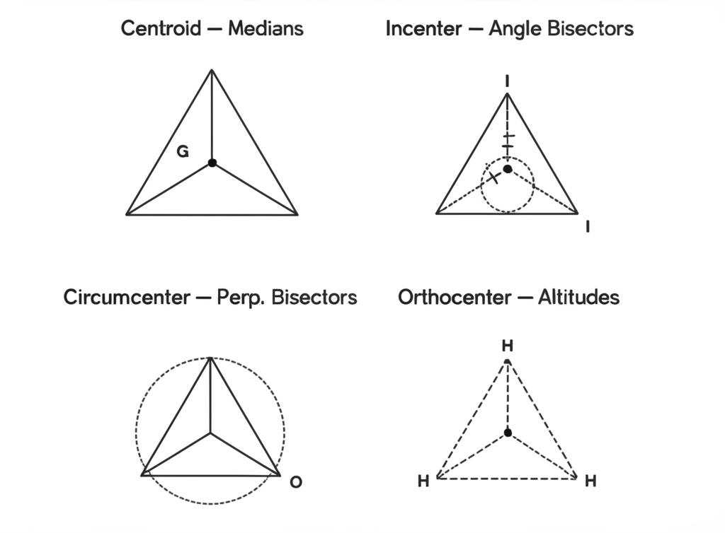
​
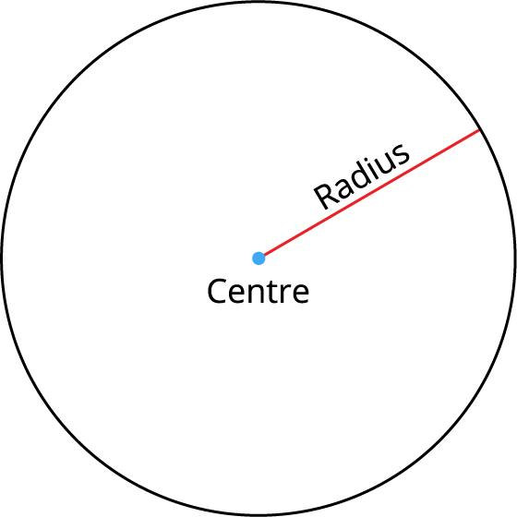
​
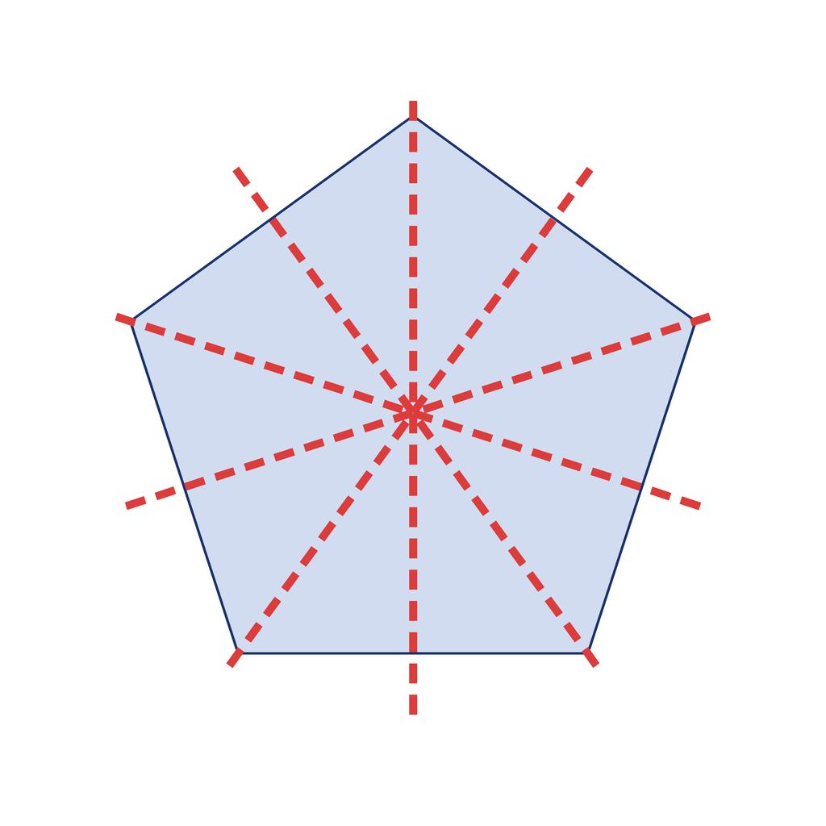
​
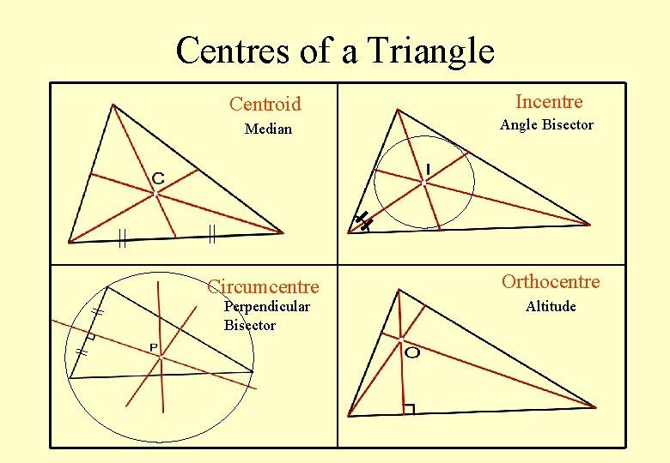
​
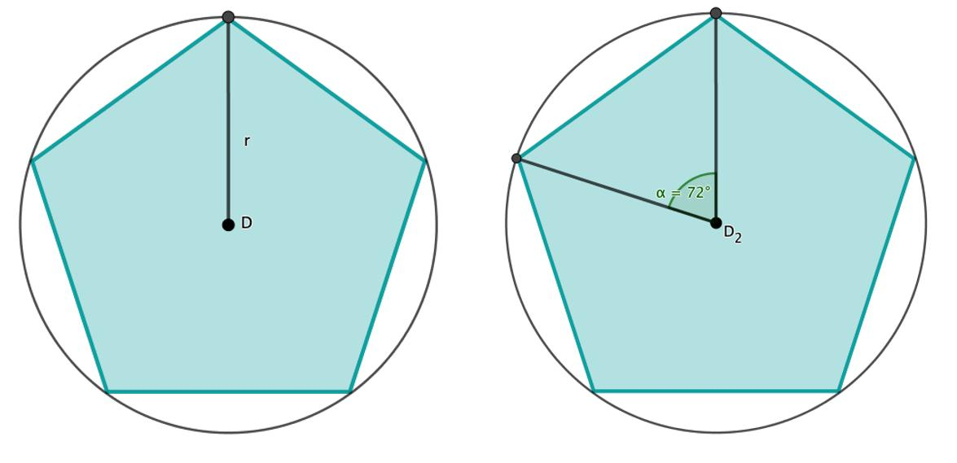

Purpose
# Source: AI Source: Provided by: [Data Path: Persons Table -> ID Column: 1, Name_En Column: Motasem Essam] -> From: [ChatGPT] on [7/25/2026]
Centers in plane geometry are used to:
- Identify important reference points.
- Describe symmetry and balance.
- Measure distances from a common point.
- Construct circles and other figures.
- Solve geometric problems.
- Define important triangle properties.
- Analyze rotational and line symmetry.
- Connect different geometric relationships.

Main Centers in Plane Geometry
# Source: AI Source: Provided by: [Data Path: Persons Table -> ID Column: 1, Name_En Column: Motasem Essam] -> From: [ChatGPT] on [7/25/2026]
There is not one universal center for every plane figure. Different figures have different types of centers.
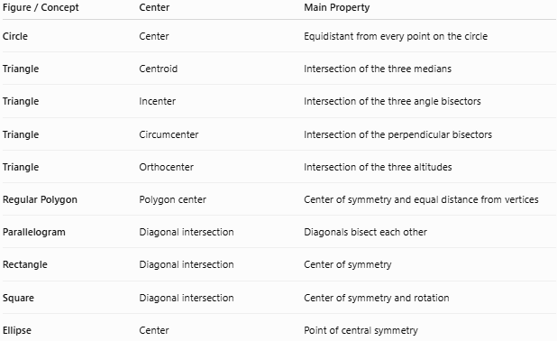
Figure / Concept | Center | Main Property
Circle | Center | Equidistant from every point on the circle
Triangle | Centroid | Intersection of the three medians
Triangle | Incenter | Intersection of the three angle bisectors
Triangle | Circumcenter | Intersection of the perpendicular bisectors
Triangle | Orthocenter | Intersection of the three altitudes
Regular Polygon | Polygon center | Center of symmetry and equal distance from vertices
Parallelogram | Diagonal intersection | Diagonals bisect each other
Rectangle | Diagonal intersection | Center of symmetry
Square | Diagonal intersection | Center of symmetry and rotation
Ellipse | Center | Point of central symmetry

1. Circle Center
# Source: AI Source: Provided by: [Data Path: Persons Table -> ID Column: 1, Name_En Column: Motasem Essam] -> From: [ChatGPT] on [7/25/2026]
The center of a circle is the point that is the same distance from every point on the circle.
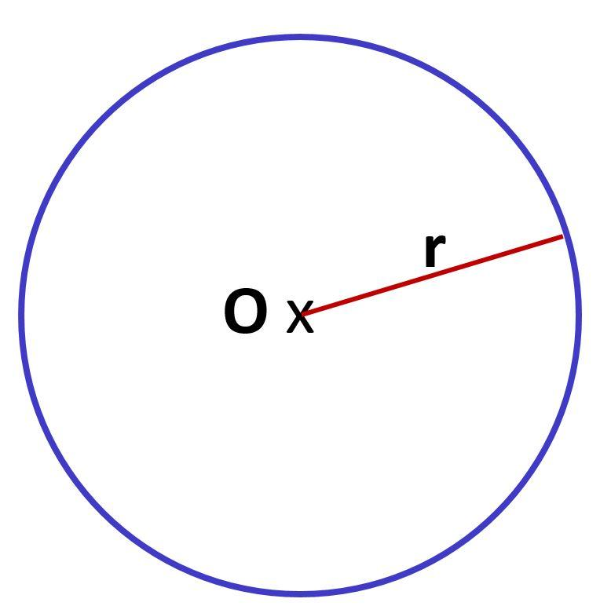​
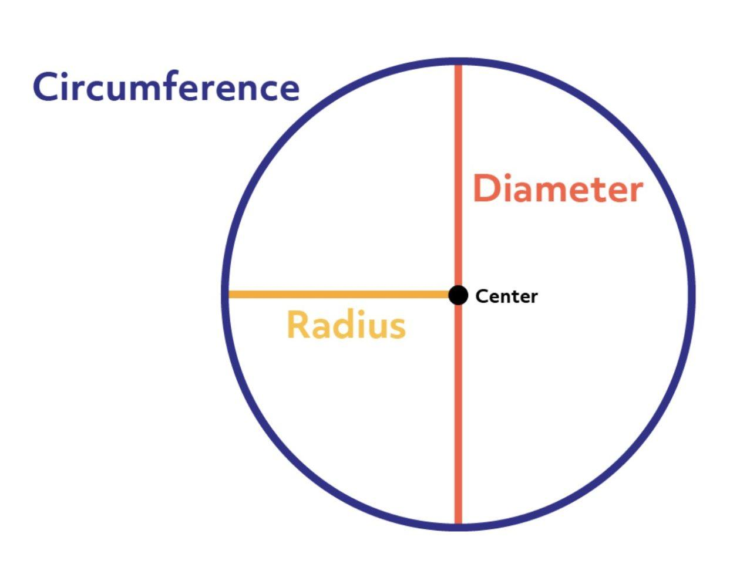
​
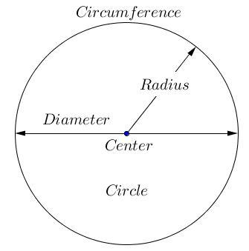
​
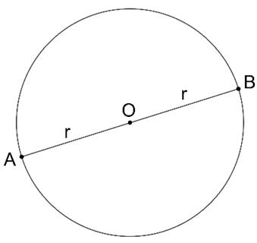
If $O$ is the center and $A$ is any point on the circle:
$$\boxed{OA=r}$$
where $r$ is the radius.
For any points $A,B,C$ on the circle:
$$\boxed{OA=OB=OC=r}$$
Circle Equation
For a circle with center:
$$(h,k)$$
and radius $r$:
$$\boxed{(x-h)^{2}+(y-k)^{2}=r^{2}}$$

2. Triangle Centers
# Source: AI Source: Provided by: [Data Path: Persons Table -> ID Column: 1, Name_En Column: Motasem Essam] -> From: [ChatGPT] on [7/25/2026]
A triangle is especially important because it has several different centers.
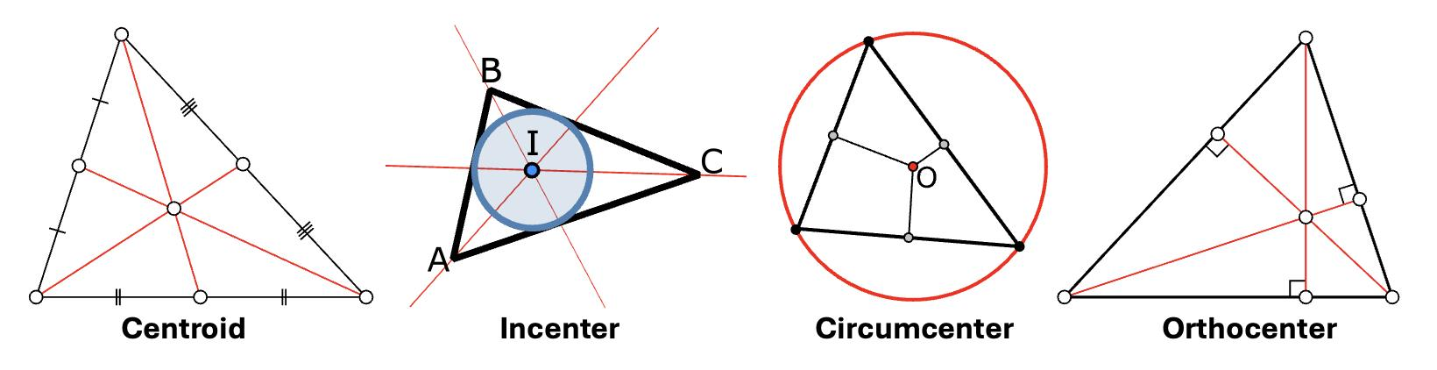
​
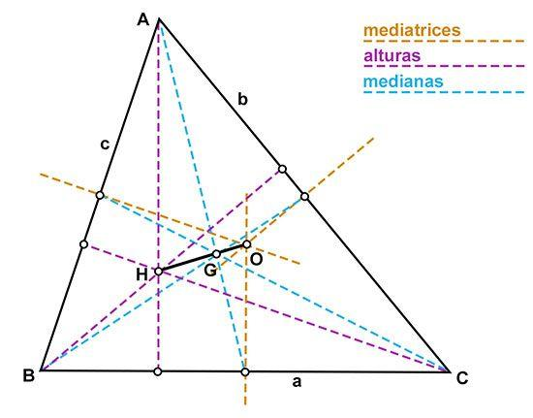
​
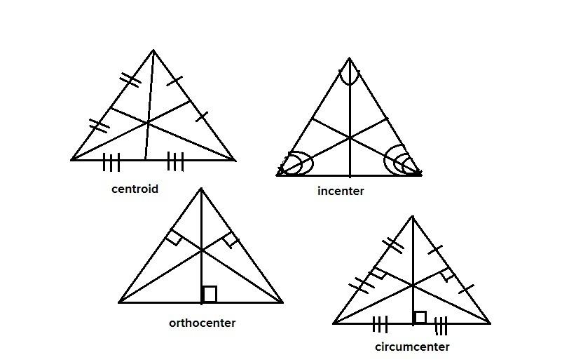
​
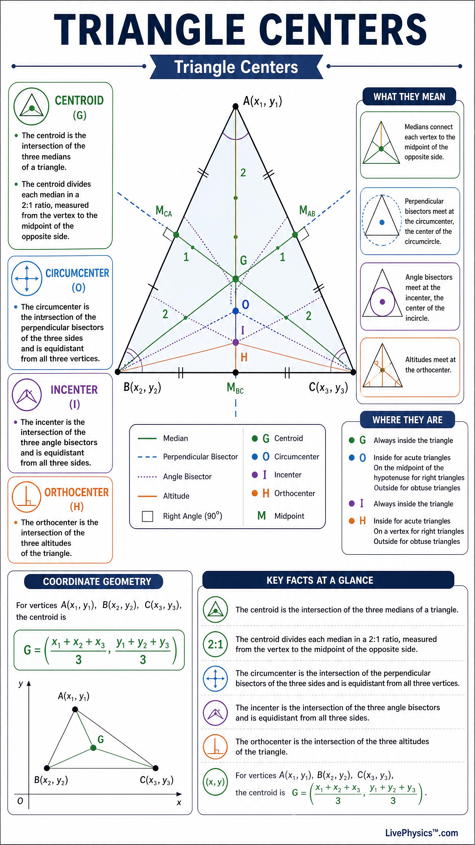
The four primary triangle centers are:

Centroid $G$
# Source: AI Source: Provided by: [Data Path: Persons Table -> ID Column: 1, Name_En Column: Motasem Essam] -> From: [ChatGPT] on [7/25/2026]
Intersection of the three medians.
$$\boxed{G=\text{intersection of medians}}$$
It represents the triangle’s center of mass.

Incenter $I$
# Source: AI Source: Provided by: [Data Path: Persons Table -> ID Column: 1, Name_En Column: Motasem Essam] -> From: [ChatGPT] on [7/25/2026]
Intersection of the three angle bisectors.
$$\boxed{I=\text{intersection of angle bisectors}}$$
It is the center of the incircle.

Circumcenter $O$
# Source: AI Source: Provided by: [Data Path: Persons Table -> ID Column: 1, Name_En Column: Motasem Essam] -> From: [ChatGPT] on [7/25/2026]
Intersection of the three perpendicular bisectors.
$$\boxed{O=\text{intersection of perpendicular bisectors}}$$
It is the center of the circumcircle.

Orthocenter $H$
# Source: AI Source: Provided by: [Data Path: Persons Table -> ID Column: 1, Name_En Column: Motasem Essam] -> From: [ChatGPT] on [7/25/2026]
Intersection of the three altitudes.
$$\boxed{H=\text{intersection of altitudes}}$$

3. Polygon Center
# Source: AI Source: Provided by: [Data Path: Persons Table -> ID Column: 1, Name_En Column: Motasem Essam] -> From: [ChatGPT] on [7/25/2026]
A regular polygon has a well-defined center.
For a regular polygon, the center is:
- Equidistant from all vertices.
- Equidistant from all sides.
- The center of its circumscribed circle.
- The center of its inscribed circle.
- A center of rotational symmetry.
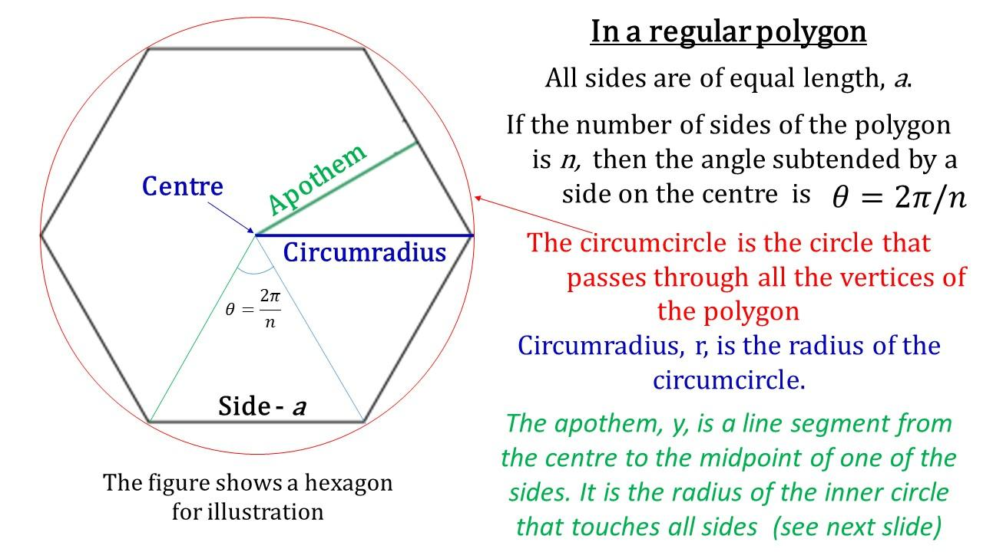
​
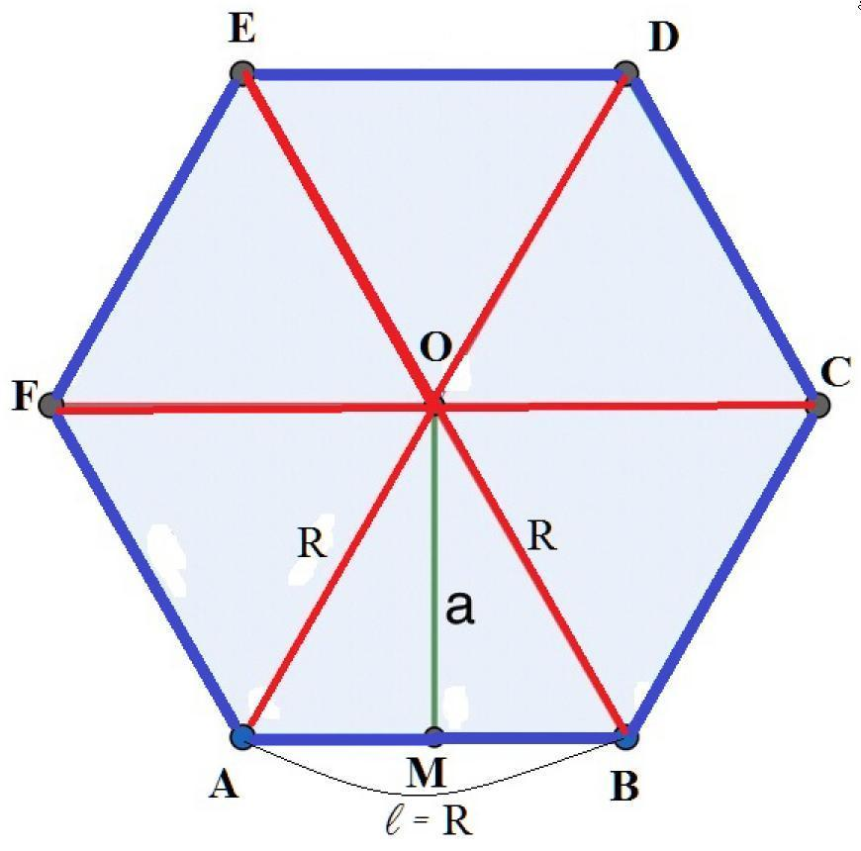
​
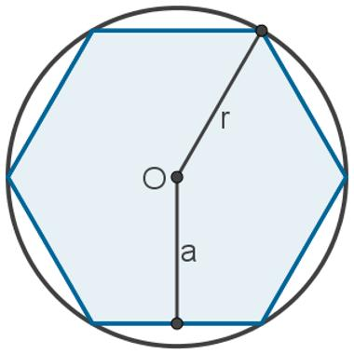
​
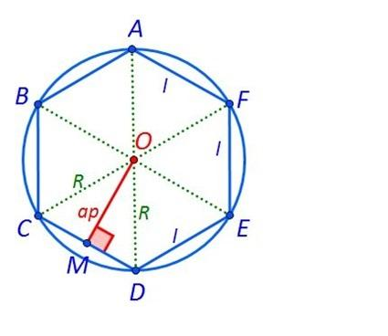
​
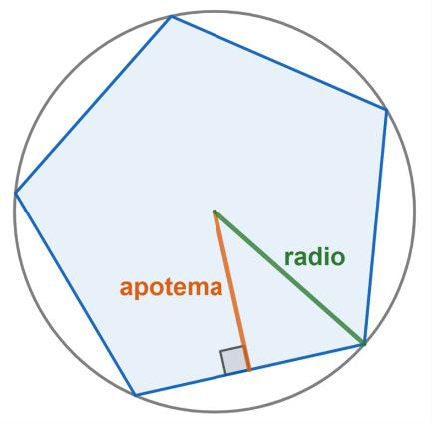
For a regular polygon:
$$\boxed{OA=OB=OC=⋯}$$
where $O$ is the center and $A,B,C,…$ are the vertices.

4. Quadrilateral Centers
# Source: AI Source: Provided by: [Data Path: Persons Table -> ID Column: 1, Name_En Column: Motasem Essam] -> From: [ChatGPT] on [7/25/2026]
Some quadrilaterals have a natural center.

Parallelogram
# Source: AI Source: Provided by: [Data Path: Persons Table -> ID Column: 1, Name_En Column: Motasem Essam] -> From: [ChatGPT] on [7/25/2026]
The diagonals of a parallelogram bisect each other.
If diagonals $AC$ and $BD$ intersect at $O$:
$$\boxed{AO=OC}$$
and:
$$\boxed{BO=OD}$$
Therefore, $O$ is the center of symmetry of the parallelogram.
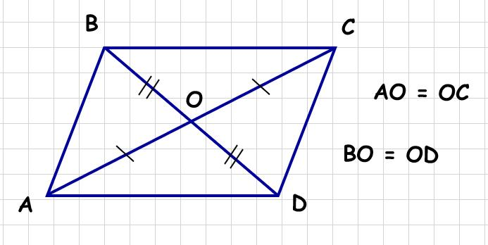
​
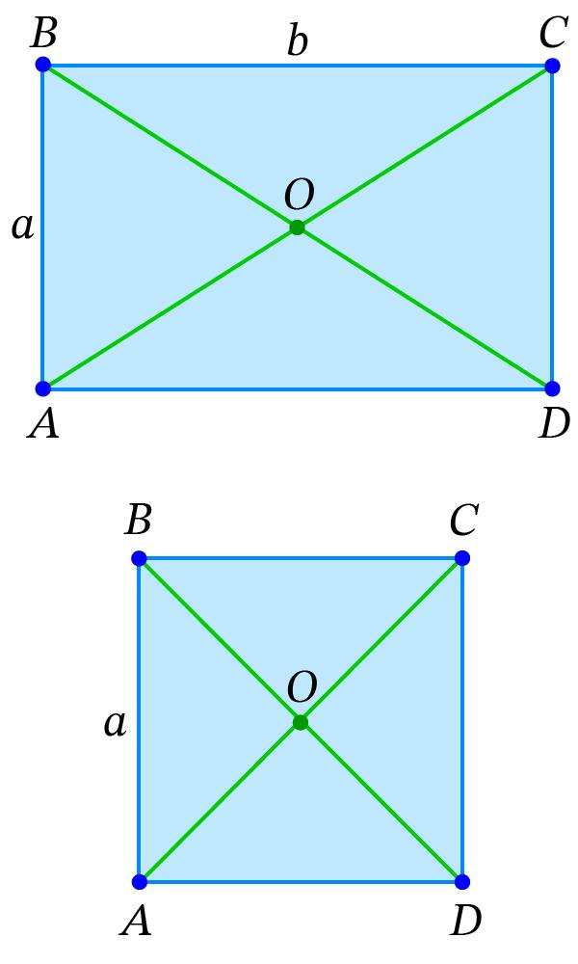
​
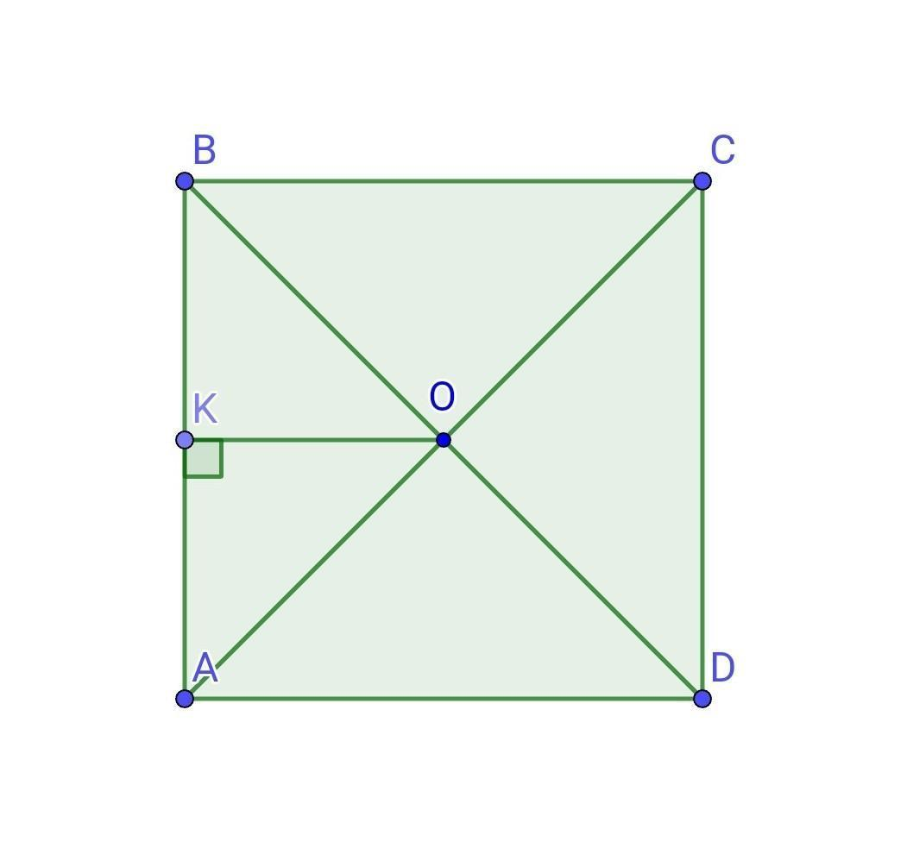
​
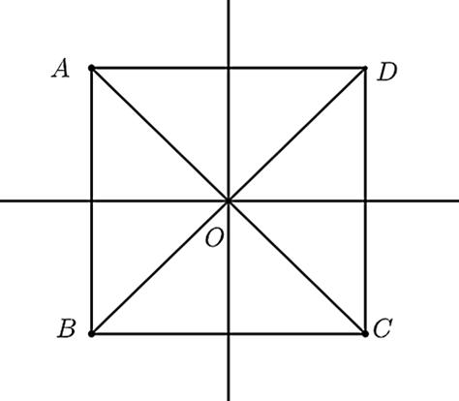

Rectangle
# Source: AI Source: Provided by: [Data Path: Persons Table -> ID Column: 1, Name_En Column: Motasem Essam] -> From: [ChatGPT] on [7/25/2026]
The diagonals of a rectangle intersect at its center.
Therefore:
$$\boxed{AO=OC}$$
and:
$$\boxed{BO=OD}$$
The center is also equidistant from all four vertices:
$$\boxed{OA=OB=OC=OD}$$

Square
# Source: AI Source: Provided by: [Data Path: Persons Table -> ID Column: 1, Name_En Column: Motasem Essam] -> From: [ChatGPT] on [7/25/2026]
A square has an especially significant center.
Its center is:
- The intersection of the diagonals.
- The center of rotational symmetry.
- The center of the circumscribed circle.
- The center of the inscribed circle.
Thus:
$$\boxed{O=\text{intersection of diagonals}}$$

5. Ellipse Center
# Source: AI Source: Provided by: [Data Path: Persons Table -> ID Column: 1, Name_En Column: Motasem Essam] -> From: [ChatGPT] on [7/25/2026]
An ellipse has a center of symmetry.
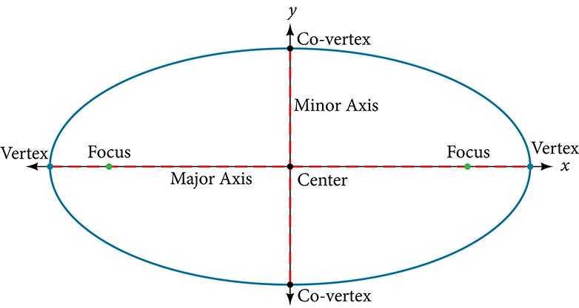
​
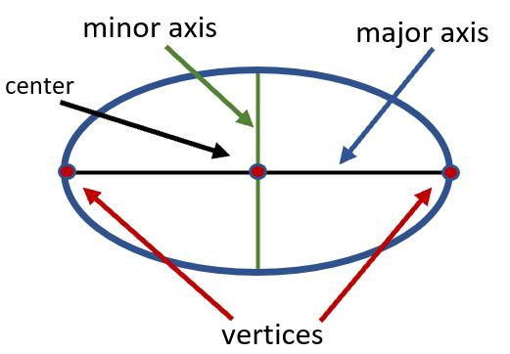
​
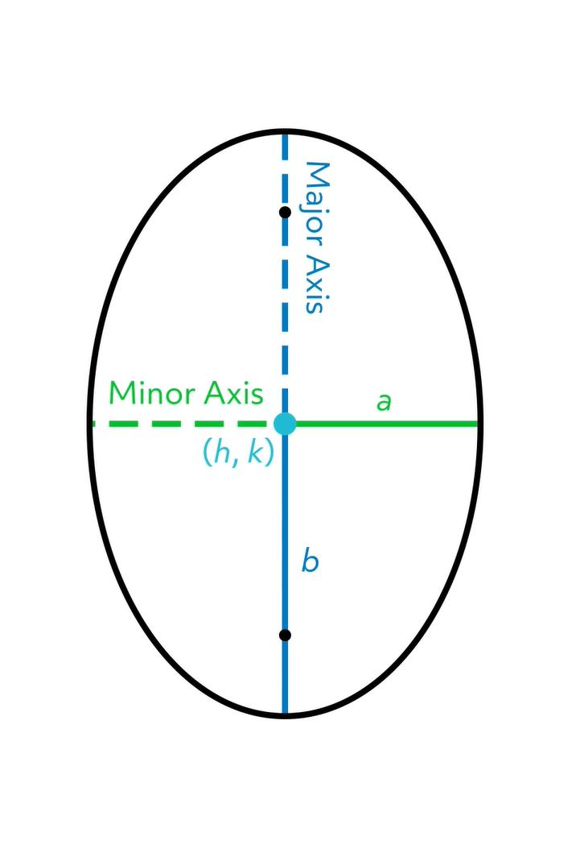
​
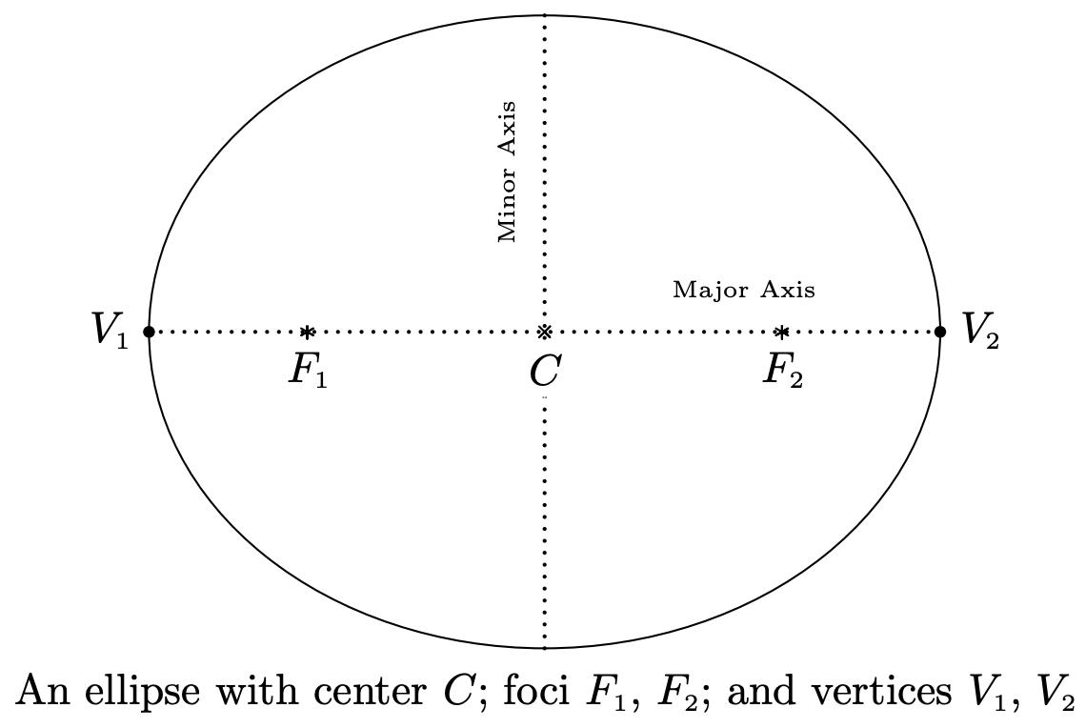
For an ellipse:
$$\boxed{\frac{(x-h)^{2}}{a^{2}}+\frac{(y-k)^{2}}{b^{2}}=1}$$
the center is:
$$\boxed{(h,k)}$$
The center is the midpoint of both the major axis and minor axis.

Center and Symmetry
# Source: AI Source: Provided by: [Data Path: Persons Table -> ID Column: 1, Name_En Column: Motasem Essam] -> From: [ChatGPT] on [7/25/2026]
A center is often strongly related to symmetry.
A figure has central symmetry if rotating it ${180}^{∘}$ about a point produces the same figure.
That point is called the center of symmetry.
For example:
- Parallelogram → center at diagonal intersection.
- Rectangle → center at diagonal intersection.
- Square → center at diagonal intersection.
- Circle → its center.
- Ellipse → its center.
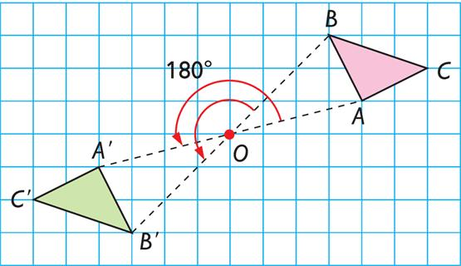
Image
​
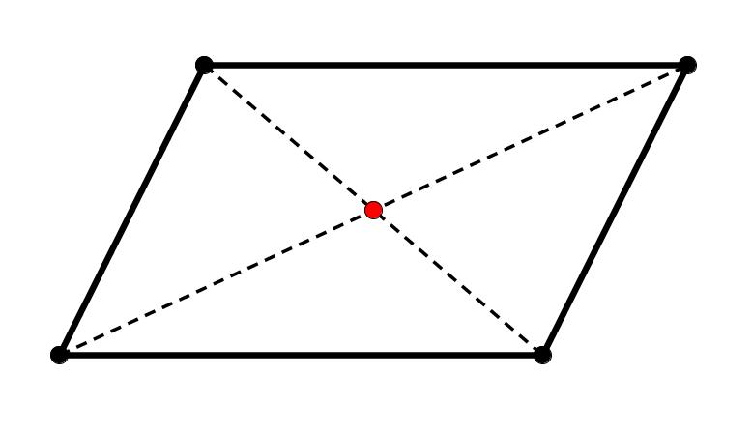
Image 2
​
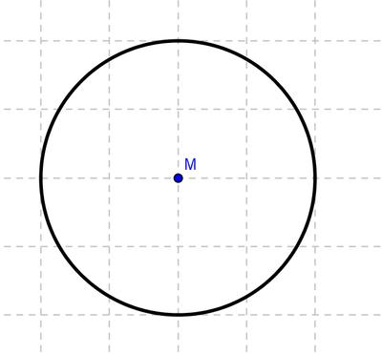
Image 3
​
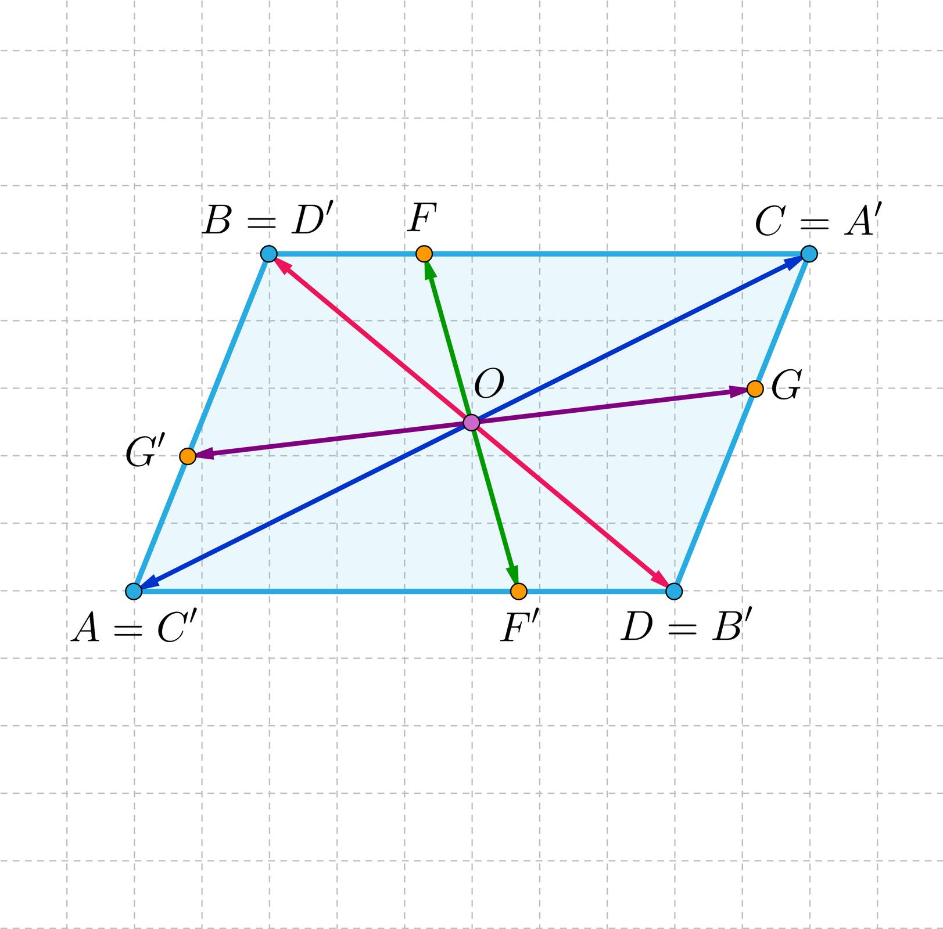
Image 4

Center vs. Centroid
# Source: AI Source: Provided by: [Data Path: Persons Table -> ID Column: 1, Name_En Column: Motasem Essam] -> From: [ChatGPT] on [7/25/2026]
These terms should not be treated as identical.

Center
# Source: AI Source: Provided by: [Data Path: Persons Table -> ID Column: 1, Name_En Column: Motasem Essam] -> From: [ChatGPT] on [7/25/2026]
A general term for an important point associated with a figure.

Centroid
# Source: AI Source: Provided by: [Data Path: Persons Table -> ID Column: 1, Name_En Column: Motasem Essam] -> From: [ChatGPT] on [7/25/2026]
A specific geometric center, especially for triangles and other regions.
For a triangle:
$$\boxed{\text{Centroid}=G}$$
The centroid is specifically determined by the intersection of the medians.

Center vs. Circumcenter
# Source: AI Source: Provided by: [Data Path: Persons Table -> ID Column: 1, Name_En Column: Motasem Essam] -> From: [ChatGPT] on [7/25/2026]
These are also different concepts.
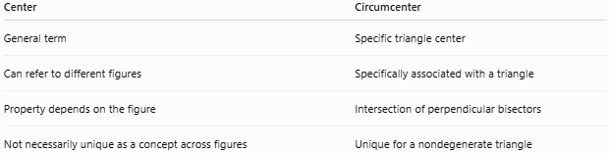
Center | Circumcenter
General term | Specific triangle center
Can refer to different figures | Specifically associated with a triangle
Property depends on the figure | Intersection of perpendicular bisectors
Not necessarily unique as a concept across figures | Unique for a nondegenerate triangle

Triangle Centers Compared
# Source: AI Source: Provided by: [Data Path: Persons Table -> ID Column: 1, Name_En Column: Motasem Essam] -> From: [ChatGPT] on [7/25/2026]
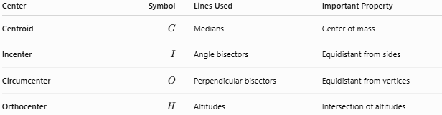
Center | Symbol | Lines Used | Important Property
Centroid | $G$​ | Medians | Center of mass
Incenter | $I$​ | Angle bisectors | Equidistant from sides
Circumcenter | $O$​ | Perpendicular bisectors | Equidistant from vertices
Orthocenter | $H$​ | Altitudes | Intersection of altitudes
A useful memory rule is:
$$\boxed{\begin{matrix}\text{Median}→G \\ \text{Angle Bisector}→I \\ \text{Perpendicular Bisector}→O \\ \text{Altitude}→H\end{matrix}}$$

Special Case: Equilateral Triangle
# Source: AI Source: Provided by: [Data Path: Persons Table -> ID Column: 1, Name_En Column: Motasem Essam] -> From: [ChatGPT] on [7/25/2026]
In an equilateral triangle, the four primary triangle centers coincide.
$$\boxed{G=I=O=H}$$
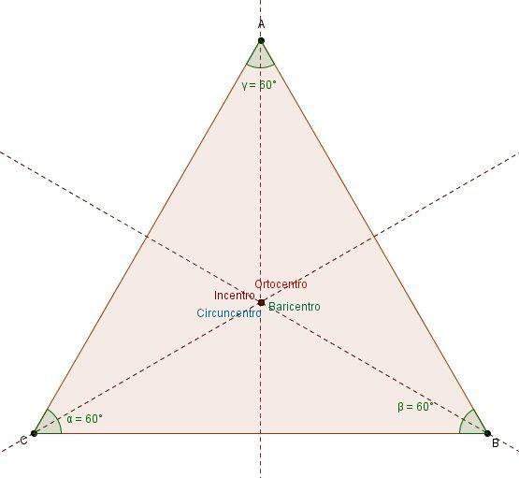
Image
​
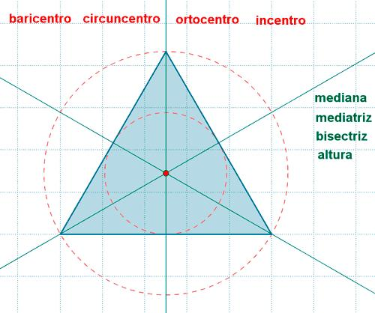
Image 2
​
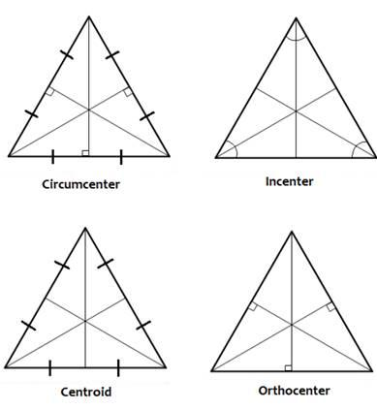
Image 3
The same point is simultaneously:
- Centroid
- Incenter
- Circumcenter
- Orthocenter
And the relevant lines coincide:
$$\boxed{\text{Median}=\text{Altitude}=\text{Angle Bisector}=\text{Perpendicular Bisector}}$$

Mathematical Importance
# Source: AI Source: Provided by: [Data Path: Persons Table -> ID Column: 1, Name_En Column: Motasem Essam] -> From: [ChatGPT] on [7/25/2026]
Centers help transform complicated geometric problems into simpler relationships.
For example:

Equal distances
# Source: AI Source: Provided by: [Data Path: Persons Table -> ID Column: 1, Name_En Column: Motasem Essam] -> From: [ChatGPT] on [7/25/2026]
Circumcenter:
$$\boxed{OA=OB=OC}$$

Equal distances from sides
# Source: AI Source: Provided by: [Data Path: Persons Table -> ID Column: 1, Name_En Column: Motasem Essam] -> From: [ChatGPT] on [7/25/2026]
Incenter:
$$\boxed{d(I,AB)=d(I,BC)=d(I,CA)}$$

Median ratio
# Source: AI Source: Provided by: [Data Path: Persons Table -> ID Column: 1, Name_En Column: Motasem Essam] -> From: [ChatGPT] on [7/25/2026]
Centroid:
$$\boxed{AG:GD=2:1}$$

Perpendicular relationships
# Source: AI Source: Provided by: [Data Path: Persons Table -> ID Column: 1, Name_En Column: Motasem Essam] -> From: [ChatGPT] on [7/25/2026]
Orthocenter:
$$\boxed{H\text{ lies on all three altitudes}}$$

Applications
# Source: AI Source: Provided by: [Data Path: Persons Table -> ID Column: 1, Name_En Column: Motasem Essam] -> From: [ChatGPT] on [7/25/2026]
Centers in plane geometry are used in:
- Circle construction.
- Triangle construction.
- Finding centers of symmetry.
- Finding centers of mass.
- Calculating distances.
- Coordinate geometry.
- Architecture.
- Engineering.
- Computer graphics.
- Physics.
- Surveying.
- Geometric transformations.

Advantages
# Source: AI Source: Provided by: [Data Path: Persons Table -> ID Column: 1, Name_En Column: Motasem Essam] -> From: [ChatGPT] on [7/25/2026]
- Provides important reference points.
- Simplifies geometric constructions.
- Makes symmetry easier to identify.
- Helps solve distance and angle problems.
- Connects different geometric theorems.
- Provides useful coordinate formulas.
- Helps describe the structure of geometric figures.

Limitations
# Source: AI Source: Provided by: [Data Path: Persons Table -> ID Column: 1, Name_En Column: Motasem Essam] -> From: [ChatGPT] on [7/25/2026]
- Not every plane figure has a single universally defined “center.”
- Different figures may have different types of centers.
- A triangle has several distinct centers rather than one universal center.
- Some centers can lie outside the figure, such as the circumcenter or orthocenter of an obtuse triangle.
- The meaning of “center” must therefore be determined from the geometric figure and context.

Key Points
# Source: AI Source: Provided by: [Data Path: Persons Table -> ID Column: 1, Name_En Column: Motasem Essam] -> From: [ChatGPT] on [7/25/2026]
- A center is an important reference point associated with a geometric figure.
- A circle has a center equidistant from all points on the circle.
- A triangle has four primary centers:
  - Centroid $G$ → medians.
  - Incenter $I$ → angle bisectors.
  - Circumcenter $O$ → perpendicular bisectors.
  - Orthocenter $H$ → altitudes.
- Regular polygons have a center associated with their symmetry.
- Parallelograms, rectangles, and squares have centers of symmetry at the intersection of their diagonals.
- A figure can have more than one meaningful type of center.
- In an equilateral triangle:
$$\boxed{G=I=O=H}$$

Conclusion
# Source: AI Source: Provided by: [Data Path: Persons Table -> ID Column: 1, Name_En Column: Motasem Essam] -> From: [ChatGPT] on [7/25/2026]
In plane geometry, a center is a significant point that describes an important property of a geometric figure, such as symmetry, equal distances, balance, or intersection of special lines. The concept becomes particularly rich in triangles, which have the centroid, incenter, circumcenter, and orthocenter. Centers therefore provide a unified way to study the structure, symmetry, measurements, and relationships of two-dimensional geometric figures.

